 | Wayne's Word |  | Index |  | Noteworthy Plants |  | Trivia |  | Lemnaceae |  | Biology 101 |  | Botany |  | Search

WAYNE'S WORD Volume 8 (Number 1) Spring 1999

Devil's Claws

A Plant That Hitchhikes On Big Animals

Major Topics To Be Discussed:
A Brief Introduction To Devil's Claws
Dispersal Of Devil's Claws By Big Animals
Devil's Claw Species In The Americas
Use Of Devil's Claws By Native Americans
Devil's Claws In Death Valley, California
Cultivation Of Devil's Claws
Where To Purchase Devil's Claws
References About Devil's Claws

Introduction
There are literally thousands of species of beautiful wildflowers in North America, but some of the loveliest and most interesting are called devil's claws. They produce strange seed pods that attach to the feet and legs of large animals, and include some of the largest hitchhiker fruits in the world.
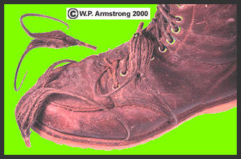
Devil's claws (Proboscidea louisianica) hitchhiking on a shoe.
The devil's claw fruit is technically a drupaceous capsule with a woody inner part surrounded by a fleshy layer. The rather sinister common name of "devil's claw" refers to the inner woody capsule which splits open at one end into two curved horns or claws. Each capsule contains about 40 black seeds which are gradually released when the claws split apart. They are also called "elephant tusks" and readily cling to the hooves of grazing animals or your shoes if you happen to step on them. In some areas of the southwestern United States they are a nuisance to sheep ranchers because they get entangled in the fleece. In his fascinating book, Plants and Planet (1974), Anthony Huxley (son of Julian Huxley) eloquently describes the hitchhiking pods as "hookers." The fresh green pods (and dried black seed capsules) were important items in the cultures of many Indian tribes of the southwestern United States, and are still used to this day for food and in basketry. The plant is also known as "unicorn plant," referring to the large, hornlike fruit before is has split open.
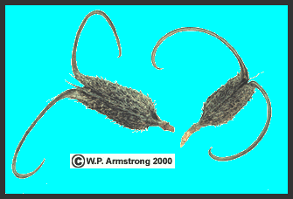
South American devil's claws (Ibicella lutea). In addition to the long, curved claws, the capsule body is covered with prickly spines. This is one of the world's most durable and ingenious hitchhikers. It can also be one of the most painful if you get a claw imbedded in your hand.

Dispersal By Big Animals: New World Anachronisms
The seed capsules of devil's claws are clearly adapted for hitchhiking on the hooves of large grazing animals; however, with the exception of introduced livestock and people (and possibly desert bighorn sheep), there are few native North American animals living within the present range of devil's claws that are capable of dispersing these large hitchhikers. It is possible that the range of some large North American grazers, such as antelope, bison, deer and elk once overlapped the range of devil's claws thousands of years ago. It is also possible that devil's claw dispersal by grazing mammals may be a North and South American anachronism, or an occurrence that is out of its proper time in history. During the past one million years of the Pleistocene Epoch, the Americas were rich in large mammals (such as giant ground sloths) which are now extinct. Assuming devil's claw plants existed over 600,000 years ago, were some of these ancient mammals the true carriers of these hitchhiker pods? A similar anachronism occurs in the New World tropics of Central and South America, where the natural dispersal agent for some large seed pods are unknown.
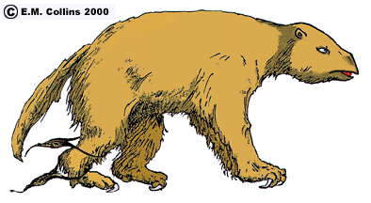
With the exception of introduced cattle, donkeys and horses, no native mammals of the New World tropics can crush the hard, thick-walled pods of many rain forest trees in their jaws. Livestock apparently like the sweet pulp inside the pods of West Indian locust (Hymenaea courbaril) and disperse the hard, viable seeds in their excrement. In areas without livestock, the rotting pods litter the ground beneath large trees. Agoutis, tapirs and peccaries chew open the rotting pods and eat the sweet pulp and seeds, but are not major agents of seed dispersal like the larger hoofed mammals. According to the authority on Central American rain forests, Daniel H. Janzen (Science Vol. 215, 1982), large grazing mammals, including extinct pleistocene elephants called gomphotheres, may have once eaten the pods and dispersed the seeds in lowland forests. In Africa, the large woody pods of related species are quickly devoured by large herbivores. There are other Central American rain forest trees that also appear to be missing their natural herbivorous dispersal agents. Their hard, woody, indehiscent fruits pile up beneath the branches and slowly rot away in the soggy, moldy layer of soil and debris. The lack of natural dispersal agents may also apply to devil's claw pods that litter the ground in temperate regions of the New World.
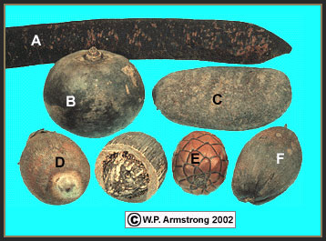
Hard, woody fruits of some Central and South American rain forest trees were likely dispersed by large prehistoric herbivores thousands of years ago. A. Cassia grandis (legume family--Fabaceae); B. Crescentia alata (bignonia family--Bignoniaceae); C. Hymenaea courbaril (legume family--Fabaceae); and the palms (Arecaceae): D. Attalea speciosa (one fruit cut open to reveal thick, woody pericarp); E. Raphia taedigera; and F. Orbignya cohune.

Calabash Gourds That Grow On Trees
See The Swamp Palm Of Costa Rica

Devil's Claw Species In The Americas
There are actually two species of devil's claws native to the southwestern United States, an attractive pink-flowered annual (Proboscidea parviflora ssp. parviflora) and a brilliant yellow-flowered perennial (P. althaeifolia). Both species form sprawling, pumpkin-like plants with clammy, sticky foliage during the hot summer months, long after most other wildflowers have bloomed and gone to seed. The generic name Proboscidea is derived from the Greek word proboskis, referring to the long beak or horn of the fruit. One plant may produce 50 or more of the curious pods which ripen by late summer and early fall. They belong to the Martynia Family (Martyniaceae), a small family comprising three genera and a dozen species, mostly of warm subtropical and desert regions of North America. The Martynia Family is closely related to the Bignonia Family (Bignoniaceae) and the blossoms of devil's claw plants are strikingly similar to those of Catalpa, Jacaranda and Bignonia. Several species of bees frequent the fragrant blossoms, which often have bright yellow nectar guide lines and reddish-purple flecks along the inner corolla tube. The two-lipped thigmotropic (contact movement) stigma of some species closes with the slightest touch, presumably capturing pollen as in several species of related wildflowers including Mimulus and Diplacus. In fact, Proboscidea annuals in cultivation readily cross pollinate, resulting in an interesting array of intermediate floral characteristics.
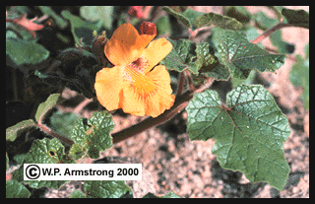
Blossoms of the yellow-flowered devil's claw (Proboscidea althaeifolia) appear during the hottest months of summer, and are one of the most spectacular of all North American desert wildflowers.
Several additional annual species of devil's claw in three different genera are naturalized or cultivated in the Pacific states. Proboscidea louisianica ssp. louisianica has large pinkish-white flowers and is native to the southern United States. It is sometimes grown in gardens, but the strongly-scented foliage is considered unpleasant and "overpowering" to some gardeners. Proboscidea louisianica ssp. fragrans, a similar devil's claw from Texas and northeastern Mexico with beautiful violet to reddish- purple flowers, is also grown in summer gardens. A robust, yellow- flowered species, Ibicella lutea (Proboscidea lutea), is occasionally naturalized in the Central Valley of California. It is native and cultivated for food in several countries of South America, from Brazil to Argentina. The dried seed capsule of the latter species is unique among devil's claw plants because the body is covered with short, prickly spines, thus making it a doubly effective hitchhiker. The generic name Ibicella is appropriately derived from ibex, a Himalayan mountain goat with magnificent curved horns.
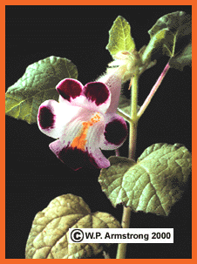
Martynia annua, a colorful tropical devil's claw produces seed capsules that resemble the upper jaw and fangs of a pit viper. The yellow lines in the corolla throat are nectar guide lines to direct pollinator bees to the nectar source.
Another pink-flowered annual with unusually small seed pods, Martynia annua, is native to Mexico and Central America and is naturalized throughout tropical regions of the world. Martynia, the type genus from which the family is named, commemorates Dr. John Martyn, professor of botany at Cambridge University during the eighteenth century. The sun-bleached seed capsule of Martynia, with its short, fang-like claws, superficially resembles the upper jaw and skull of a pit viper. In novelty shops of Mexico the pods of Martynia annua are hooked around a central disk to form a clever decorative sunflower. Mr. Wolffia recently purchased a necklace from Nepal strung with a variety of brightly colored wooden beads and polished seeds, including several Martynia pods.
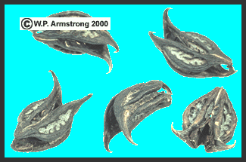
The peculiar, hooked seed capsules of the tropical devil's claw (Martynia annua) superficially resemble the upper jaw and fangs of a pit viper.
Perhaps the most fascinating thing about devil's claw plants are the curious seed pods. When they hang in clusters on the branches the green, fleshy fruits resemble bean pods or okra. They are cultivated in gardens by Indian tribes throughout the southwest and are cooked and eaten as a vegetable. The nutritious dried seeds are rich in oil and protein and can be shelled and eaten. Sometimes the oily seeds are used to polish ollas. Mr. Wolffia found the cooked fruits quite bitter, but perhaps he didn't prepare them in the right way or use enough seasoning. In some parts of the United States they are grown and pickled like cucumbers and okra, either alone or with other vegetables. According to Dr. Robert A. Bye, Jr. (personal communication), Tarahumara Indians of Chihuahua, Mexico prepare a tea from the fruits of Martynia annua which they take to relieve headaches.
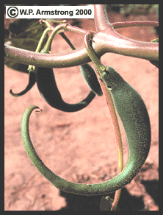
Green fruits of the pink-flowered devil's claw (Proboscidea parviflora ssp. parviflora) hang on the branches like curved bean pods or okra. They are cooked and eaten as a vegetable by several Indian tribes of the southwestern United States and Mexico. The name "unicorn plant" is derived from the unopened pods which have a single curved horn.
With some clever imagination and a few items such as bird feathers, glue and simulated eyeballs, devil's claw seed capsules can be transformed into some of the strangest creatures you have ever seen. Sometimes you can find them for sale in curio shops, painted like birds or even wearing clothing. In fact, Mr. Wolffia's fascination with these plants dates back to his childhood when he purchased a brightly painted devil's claw pod in a store near Twentynine Palms, California. Devil's claws also make an interesting mobile, clinging tenaciously to one another from the ceiling. Since our native southwest devil's claw plants are only occasionally found and because they are easy to grow, it is perhaps more ecologically sound to grow your own plants if you desire large quantities of the seed pods. [See the seed source under Cultivation Of Devil's Claws.]

Devil's Claws Used By Indians Of The S.W. United States
Many native plants have been used extensively by southwest Indians, but one of the most amazing is the devil's claw. By far the most widely used and highly prized species is the large-fruited, pink-flowered annual Proboscidea parviflora ssp. parviflora. Peter Bretting of Indiana University has named two varieties of the pink-flowered devil's claw, a wild black-seeded type (var. parviflora) and a domesticated white-seeded race (var. hohokamiana). The white-seeded cultivar (var. hohokamiana) has been cultivated for generations on several Indian rancherias in Arizona for its superior basket-making qualities. Known to the Indians as 'ihug (pronounced EE-hook), the striking seed capsules may have claws up to 15 inches (38 cm) long. Multiclawed forms of both varieties were also selected by Indians because the horns split into 3-4 claws. According to Indian folk lore, multiclawed pods were avoided by some basket makers because of the increased likelihood of having twins. Like the famous rugs and blankets of Navajo Indians, the baskets of Papago Indians are well-known for their durability, beauty and intricate designs. The four basic colors in the baskets are white, black, green and red. White is from sun-bleached dried yucca leaves (often from Yucca elata), while green is from unbleached dried yucca leaves. A red dye obtained from yucca roots is sometimes used to color the leaves. Narrow strips of yucca leaves are tightly wound around slender, fibrous bundles of beargrass leaves (often from Nolina microcarpa) producing the unique coils of the baskets. If you look closely between the coils of yucca leaves you can see the bundles of beargrass leaves.
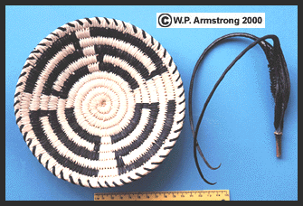
A Papago basket and the dried seed capsule of the pink-flowered devil's claw (Proboscidea parviflora ssp. parviflora). The white patterns are from dried, sun-bleached yucca leaves (Yucca elata). Narrow strips from the devil's claw pod are used for the striking black designs.

See Another Beautiful Papago Basket
When dried the devil's claw seed capsules look as though they were sprayed with flat black paint. Claws gathered for basketry were sometimes buried to preserve the dark black color. The dried capsules are soaked in water and the long, curved claws are split lengthwise into narrow strips. The pliable black strips (like strips of black leather) are tightly coiled around bundles of beargrass leaves to produce the dark patterns. Since the black color is part of the actual capsule and not a dye it will last indefinitely and makes a striking contrast with the white yucca leaves. The closeness of weave and the elaborate designs obtained by alternating strands of white yucca leaves with strands of black devil's claws are quite remarkable.
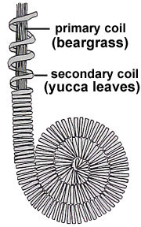 | General structure of a devil's claw basket. The primary coils are made from slender, fibrous bundles of beargrass leaves (often Nolina microcarpa). Secondary coils are made from narrow strips of yucca leaves which are tightly wound around the slender beargrass bundles. White secondary coils are from sun-bleached dried yucca leaves (often Yucca elata), while green coils are from unbleached dried yucca leaves. Pliable black strips of devil's claw horns are tightly coiled around the beargrass leaves to produce the dark patterns.
Other tribes of southwest Indians, such as the Pima, Havasupai, Apache, Yavapai, Chemehuevi, Hopi, Shoshone and Paiute utilized strips of devil's claws for black designs in their baskets. Depending on the tribe and availability of plant materials, strips of stems from willow (Salix), cottonwood (Populus), rush (Juncus), or squaw bush (Rhus trilobata) were used in place of yucca leaves, and strips of stems from cattail (Typha), tule (Scirpus) or willow were used in place of beargrass leaves. In his fascinating book entitled The Basket Weavers of Arizona (1954), Bert Robinson describes a plausible origin for devil's claws in Pima basketry: "In all probability, the first baskets made by the Pimas were woven entirely of willow or cottonwood, but the sharp sand around the cooking fire soon cut out the stitches on the surface exposed to the ground, especially if the basket was heavily laden. It is possible the ancient basket weaver, seeking something that would withstand more wear, found that the devil's claw, which fastened itself about her ankle as she walked through the fields, possessed the strength and toughness she was looking for." To this day, the center of the bottom of Pima baskets, as well as the finished edge, are commonly of devil's claw.
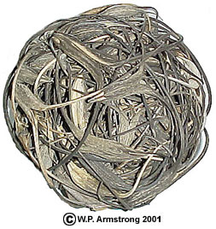 | A massive cluster of devil's claw seed capsules which provide the black designs in Pima basketry. The devil's claw pods used to make this unusual ball came from Proboscidea parviflora ssp. parviflora, a native pink-flowered species found throughout southern Arizona. The pods are often gathered and stored in ball-like clusters such as this.
Both native species of devil's claw are widespread in Arizona and Baja California, but are less common in California. The pink-flowered annual (Proboscidea parviflora ssp. parviflora) is common along the Gila River flood plain where it grows wild on the banks, along fences and in abandoned fields where there is plenty of moisture. This species was probably introduced into California because its few known locations are near abandoned Indian settlements. It has been collected from several isolated desert areas of Inyo County, including Johnson Canyon west of Death Valley, near the mouth of Hunter Canyon in remote Saline Valley and near historic Fort Independence in Owens Valley. Although Mr. Wolffia could only find a few dried seed capsules with black seeds when he visited these sites during the 1980s, some of the pods from Saline Valley appeared to be the white- seeded var. hohokamiana. The yellow-flowered perennial (P. althaeifolia) grows from a deep taproot in dry washes and along roadsides throughout the Colorado Desert, extending south to the Cape Region of Baja California. It is not commonly seen in flower because few people botanize these regions in the scorching heat of summer.

Devil's Claws In Death Valley National Monument
One of the most interesting locations for the pink- flowered devil's claw (Proboscidea parviflora ssp. parviflora) in California is Johnson Canyon, a steep canyon on the eastern side of the Panamint Range that drains into Death Valley. It can be reached from the graded West Side Road, approximately 25 miles (40 km) south of Furnace Creek Inn. A steep, rocky road climbs the alluvial fan for about six miles (10 km) before entering Johnson Canyon for another three miles (5 km). The road stops at a spring and the site of an old corral surrounded by cottonwood trees and willows. From here the canyon narrows, and a foot trail continues up the canyon to historic Hungry Bill's Ranch, and beyond to the crest of the Panamint Range.
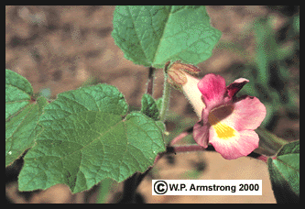
The pink-flowered Arizona devil's claw (Proboscidea parviflora ssp. parviflora) from Hungry Bill's Ranch, high in the Panamint Range west of Death Valley. This species was introduced during the late 1800s and became naturalized in this region. Note the yellow nectar guide lines--a landing strip for pollinator bees.
Hungry Bill, a tall Shoshone Indian with a reportedly enormous appetite, settled in Johnson Canyon after the downfall of Panamint City. Panamint City, located about five miles (8 km) to the west, was a rough and wild silver mining town with several thousand people in the mid 1870's. Prior to Hungry Bill's settlement, the upper Johnson Canyon bottom was cultivated by several Swiss people who raised fresh vegetables for bustling Panamint City. According to the renown naturalist Edmund C. Jaeger (writing in Desert Wildflowers, 1941), a brother of Hungry Bill visited Fort Mojave, Arizona during the 1860s and found the Indians there making black designs in their baskets from devil's claw pods. He planted seeds in Johnson Canyon where they became naturalized and still flourish to this day.

Cultivation Of Devil's Claws
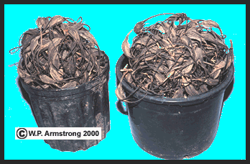
Recently harvested buckets of devil's claws (Proboscidea louisianica ssp. louisianica) at the Wayne's Word research garden.
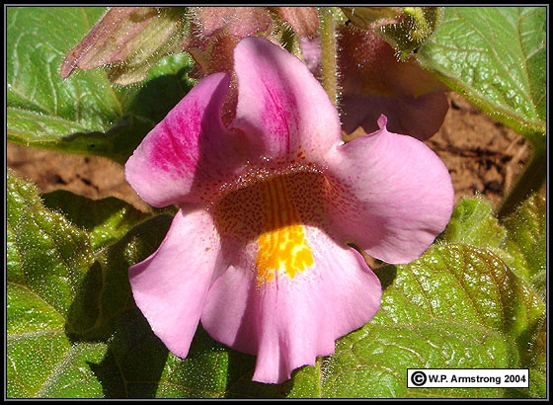
Flower of (Proboscidea louisianica ssp. louisianica) at the Wayne's Word research garden. The yellow lines in the corolla throat are nectar guide lines to direct pollinator bees to the nectar source.
Seeds of several species of devil's claw plants (Proboscidea and Martynia) are available from Native Seeds/SEARCH, 526 N. 4th Ave., Tuscon, Arizona 85705. [Phone: 520-622-5561; FAX: 520-622-5591]. The seeds may be planted in well-spaced basins or in rows 2-4 feet (1.2 m) apart, just as you would plant cucumbers or squash. You should plant the seeds in late spring when the soil is warm and there is no danger of frost. Soaking the seeds of Proboscidea parviflora ssp. parviflora in warm tap water appears to stimulate germination and increase the percentage of young seedlings. Seeds should be covered with a half inch (1.3 cm) of soil (preferably with a top layer of planter mix/mulch) and kept moist until germination. Annual devil's claw plants grow in a variety of soils, but thrive in rich loam soil with regular weekly soaking. They are very heat tolerant and their blossoms and foliage make an attractive mid-summer flower garden. Proboscidea louisianica ssp. louisianica readily reseeds itself and becomes naturalized, but poses no serious threat to your garden unless you step on one of the hooked claws barefooted.
Devil's claws are one of the most interesting and unusual plants of North America. Although they are relatively little-known to most gardeners, they have been very important in the culture of many Indian tribes. Whatever the reasons might be for growing them: As a dark strip for coiled baskets, as a vegetable crop or substitute for cucumber pickles, as an art design for bizarre little creatures, or just for their beautiful flowers and unusual seed pods; devil's claws are guaranteed to make an excellent conversation piece in the home or garden of any plant lover. But perhaps they are best enjoyed as a unique North American wildflower that brightens up a desert wash on a hot summer day.

Purchase Several Species Of Devil's Claws
Native Seeds/SEARCH
526 N. 4th Avenue
Tuscon, AZ 85705
(520) 622-5561
Native Seeds/SEARCH Website

References About Devil's Claws
- Armstrong, W.P. 1992. "Devil's Claws." Pacific Horticulture 53: 19-23.
- Armstrong, W.P. 1985. "Devil's Claw: Trademark of the Southwest." Terra 23: 16-19.
- Armstrong, W.P. 1981. "Unicorn Plants." California Garden 72: 13-19.
- Armstrong, W.P. 1980. "A Gourmet's Guide To Unicorns." Desert Magazine 43: 36-39.
- Armstrong, W.P. 1979. "Unicorn Plants in California." Fremontia 7: 16-22.
- Barlow, C. 2000. The Ghosts of Evolution. Basic Books, New York.
- Bretting, P.K. 1982. "Morphological Differentiation of Proboscidea parviflora ssp. parviflora (Martyniaceae) Under Domestication." American Journal of Botany 69: 1531-1537.
- Jaeger, E.C. 1941. Desert Wild Flowers. Stanford University Press, Stanford, California.
- Janzen, D.H., and P.S. Martin. 1982. "Neotropical Anachronisms: The Fruits the Gomphotheres Ate." Science 215: 19-27.
- Nabhan, G. P., et al. 1981. "Devil's Claw Domestication: Evidence from Southwestern Indian Fields." Journal of Ethnobiology 1: 135- 164.
- Nabhan, G. P. and A. Rea. 1987. "Plant Domestication and Folk Biological Change: The Upper Piman/Devil's Claw Example." American Anthropologist 89: 57-73.

W. P. Armstrong “Wayne’s World” website
Web site: http://waynesword.palomar.edu/ww0801.htm Accessed Oct. 5, 2005

